DEVELOPMENT – COMPARISON OF DETECTION METHODS
No | DESCRIPTION | CURCUIT | ADVANTAGES | DISADVANTAGES
1 | Photo-Resistor (LDR)  Cost – ~£2  Function – Resistance decreases with increasing incident light.  Proposed Use – Detect the presence of birds by detecting the decrease in light reaching the sensor.  Distinguish between large and small birds by the amount of decrease in light. | 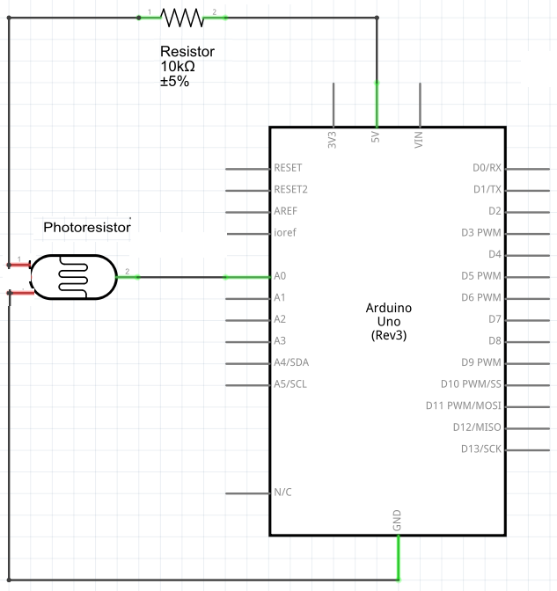 | - Simple to implement.  - Simple circuit – uses only one input port on the Arduino. | - The sensor only responds to light changes up to a maximum distance of 90mm which is much smaller than the bird table feeding area (200-300mm).  - The resistance change with distance is small and is cannot discriminate between different sized birds  - Multiple units are required in order to distinguish between a large bird far away and a small bird near to a single sensor.
2 | Accelerometer  Cost – ~£5  Function – Acceleration measurement in 3 axes.  Proposed Use - Detect the presence of birds by detecting acceleration (movement) of the table.  Distinguish between large and small birds by the amount of acceleration. | 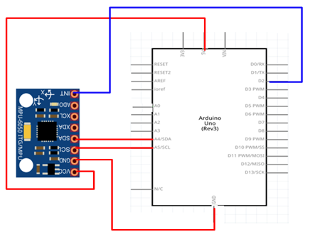 | - The sensor is capable of detecting a bird landing and determining whether the bird is small or large.  - Simple to implement – the sensor can be attached to any part of the table. | - The sensor may detect movement caused by sudden gusts of wind which may lead to a false detection or small bird being detected as a large bird and repelled.  - Acceleration depends on the setup of the bird table moves (e.g. how flexible the stand is) and detection limits and ranges would have to be adjusted for different tables
3 | Force Sensitive Resistor  Cost – ~£7  Function – Resistance decreases with increasing force.  Proposed Use - Detect the presence of birds by detecting an increase in force (weight) on the table.  Distinguish between large and small birds by the amount of force (weight). | 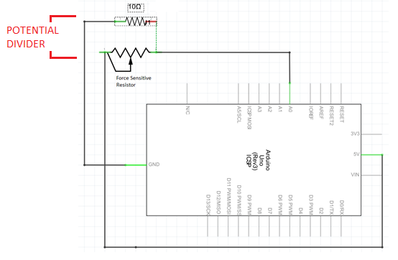 | - The sensor is capable of detecting a bird landing and determining whether the bird is small or large.  - Simple circuit – uses only one input port on the Arduino.  - SELECTED | - The table design will be more complicated because the feeding platform must be free to move relative to the sensor and all its weight must be delivered to the sensor.  - The usable force range is equivalent to a feeding platform + bird weight of 30-200g. The feeding platform must be relatively light (<75g) to allow distinguishing between small and large birds  - When a bird lands the force created will be greater than its weight because it is dropping and has momentum

